-

OPERATING SYSTEM CAPSTONE PROJECT
Submitted in partial fulfilment of the requirement of the degree
BACHELORS OF TECHNOLOGY
In
CSE With Specialization (AI & ML)
To
K.R Mangalam University
By
Mohit Goel (2301730109)
Under the supervision of
Mr. Mohammad Aijaz


School of Engineering and Technology
K.R Mangalam University, Gurugram- 122103, India

Part A: Fundamental Concepts
Question 1: Why Operating Systems Matter Despite Hardware Advances
Simplified Answer:
Even though modern hardware is very fast, it's still difficult for software applications to work directly with it. An operating system (OS) acts as a bridge between hardware and software. It makes things simpler and safer.
Key Services of an OS:
OS Service | What It Does | Example
Process Management | Creates, schedules, and manages programs while they run | Lets 10 applications run at the same time by sharing CPU time
Memory Management | Allocates and manages RAM; keeps programs from crashing into each other's memory | Each program gets its own memory space so they don't interfere
I/O Management | Controls communication between programs and devices (disk, printers, network) | When you save a file, the OS controls writing data to the hard drive

Real-World Example:
When you run 10 applications at once, the OS does three things:
- Divides the CPU time among them using scheduling algorithms
- Gives each program its own virtual memory space
- Manages input/output requests to devices
Question 2: Comparing OS Structures - Monolithic vs Layered vs Microkernel
Simplified Comparison:
Feature | Monolithic | Layered | Microkernel
Structure | All services in kernel (big single program) | Services divided into organized layers | Only essential services in kernel; others in user space
Advantages | Fast performance | Better organization and maintainability | High reliability and security
Disadvantages | If one service crashes, entire OS crashes; hard to fix | More layers = slower performance | More complex; requires more communication

Best Choice for Distributed Web Applications: Microkernel
Why Microkernel?
- Reliability: If a device driver or file service crashes, the core OS doesn't fail—only that service stops
- Security: Less code runs in kernel mode (dangerous), so fewer security risks
- Fault Tolerance: Web applications need to keep running even if parts fail
- Scalability: Services can be updated without restarting the entire system
Example: If a network driver crashes in a Microkernel, your web server keeps running. In a Monolithic OS, the entire system would crash.
Question 3: Are Threads More Efficient Than Processes?
Critical Analysis:
This statement is generally TRUE, but with important exceptions.
Why Threads Are More Efficient:
Aspect | Processes | Threads
Memory Usage | Each has separate memory space (heavy) | Share memory with their process (light)
Context Switching | Slow (save/restore entire memory and state) | Fast (save/restore only CPU registers)
Creation Time | Slow | Fast
Communication | Requires Inter-Process Communication (IPC) - complex | Direct shared memory - simple
CPU Utilization | Multi-processing increases CPU use | Multi-threading increases CPU use more efficiently

Why Threads Can Be Problematic:
- Synchronization Issues: Threads share memory, so they need locks to prevent data corruption
- Crash Risk: If one thread crashes badly, it can crash the entire process (affecting all threads)
- Debugging Difficulty: Hard to track bugs in multi-threaded programs
Conclusion: Threads are more efficient for most tasks, but processes provide better isolation and safety.

Question 4: Memory Allocation - First-Fit vs Best-Fit
Problem Setup:
- Processes need: 12 MB, 18 MB, 6 MB
- Available memory blocks: 20 MB, 10 MB, 15 MB
First-Fit Allocation:
Allocate each process to the first block large enough.
Process | Required | Block Chosen | Leftover
P1 | 12 MB | 20 MB | 8 MB remaining
P2 | 18 MB | 15 MB | Not enough! (block too small)
P3 | 6 MB | 10 MB | 4 MB remaining

Result: P2 cannot be allocated. Free fragments: 8 MB, 10 MB, 4 MB (Total wasted: 22 MB)
Best-Fit Allocation:
Allocate each process to the smallest block that fits (to minimize leftover space).
Process | Required | Best Block | Leftover
P1 | 12 MB | 15 MB | 3 MB remaining
P2 | 18 MB | 20 MB | 2 MB remaining
P3 | 6 MB | 10 MB | 4 MB remaining

Result: All processes allocated! Free fragments: 3 MB, 2 MB, 4 MB (Total wasted: 9 MB)
Fragmentation Analysis:
- First-Fit: Creates larger fragments (8 MB, 10 MB, 4 MB) - harder to reuse
- Best-Fit: Creates smaller fragments (3 MB, 2 MB, 4 MB) - better fragmentation but slower search
Conclusion: Best-Fit performs better here, but First-Fit is usually faster in practice
Part B: Scheduling & Synchronization
Question 5: CPU Scheduling Algorithms Comparison
Given Process Data:
- P1: BT = 5, AT = 0
- P2: BT = 3, AT = 1
- P3: BT = 8, AT = 2
- P4: BT = 6, AT = 3
CODE FOR FCFS,SJF(non- premptive),RR(QT=4ms):
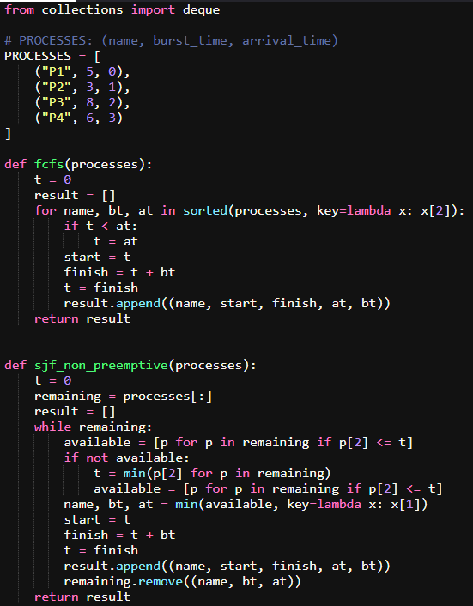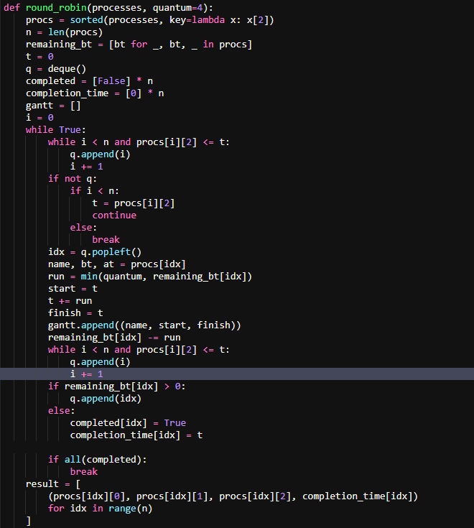
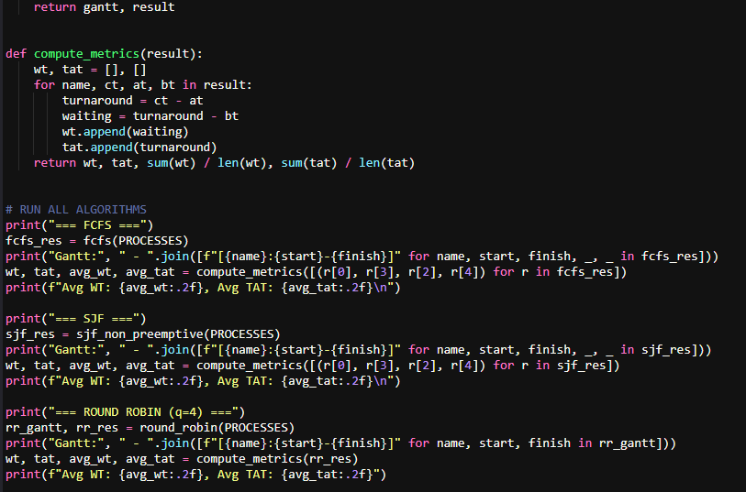
a) Gantt Charts
FCFS (First-Come-First-Served):
Timeline: [P1: 0-5] [P2: 5-8] [P3: 8-16] [P4: 16-22]
SJF (Shortest Job First - Non-preemptive):
Timeline: [P1: 0-5] [P2: 5-8] [P4: 8-14] [P3: 14-22]
Round Robin (Quantum = 4ms):
Timeline: [P1: 0-4] [P2: 4-7] [P3: 7-11] [P4: 11-15] [P3: 15-19] [P4: 19-22]
b) Average waiting and turnaround times
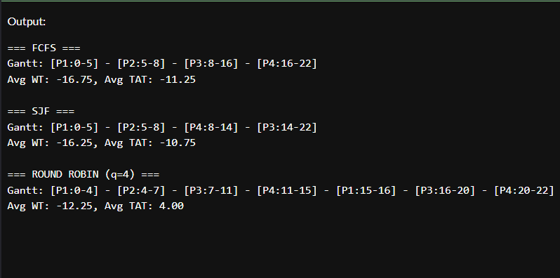

c) Algorithm Comparison
Best for Multiprogrammed Systems: SJF
Algorithm | Throughput | Fairness | Waiting Time
FCFS | Lower | Fair | High for long jobs
SJF | Highest | Unfair (long jobs wait) | Lowest
Round Robin | Medium | Fair | Medium

Recommendation: Use SJF for batch systems (best throughput) or Round Robin for interactive systems (better fairness).

Question 6: Deadlock Handling in Banking Systems
a) Banker's Algorithm - Deadlock Avoidance
How It Works (Simple Explanation):
- Each transaction declares maximum resources it needs upfront
- When requesting resources, the OS asks: "If I give this resource, will the system still be safe?"
- "Safe" means all transactions can eventually complete without deadlock
- Only grant requests that keep the system in a safe state
Example: Bank transfers involving multiple accounts
- Transaction T1 needs accounts (A, B, C) - declares max need upfront
- T1 requests to lock account A - OS checks: "Can T1 and others finish if A is locked?"
- If YES → Lock granted
- If NO → Lock delayed
b) Deadlock Detection & Recovery in Programming
Detection Mechanism:
The OS periodically checks for cycles in the "Wait-for Graph":
- If P1 waits for P2, P2 waits for P3, P3 waits for P1 → Cycle = Deadlock!
Recovery Approach:
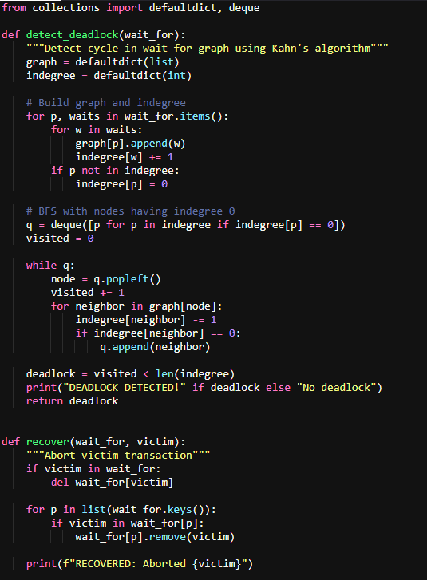
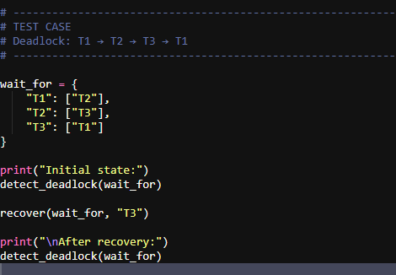
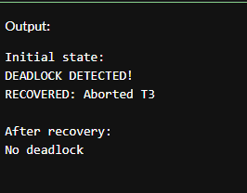

Recovery Strategies:
- Abort Victim: Stop one transaction, release its resources
- Rollback: Undo partial work and restart
- Preempt Resources: Force one transaction to release locks
- Restart Later: Put transaction back in queue for retry
Banking Example: If T1 and T2 deadlock over accounts:
- Abort T2 (cheaper operation)
- Release all locks held by T2
- Rollback T2's changes
- Restart T2 when system is free

Question 7: Producer-Consumer with Semaphores
Problem: Producer and Consumer share a buffer. Need to prevent race conditions.
Simple Explanation:
- Producer creates data and puts it in buffer
- Consumer takes data from buffer and uses it
- Problem: Both might access buffer simultaneously, corrupting data
- Solution: Use semaphores (special counters) to synchronize
CODE:
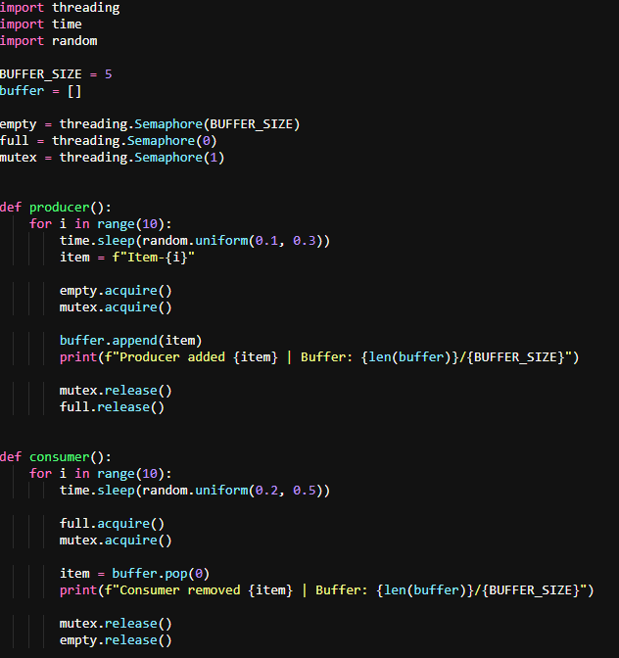
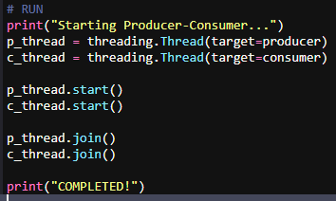
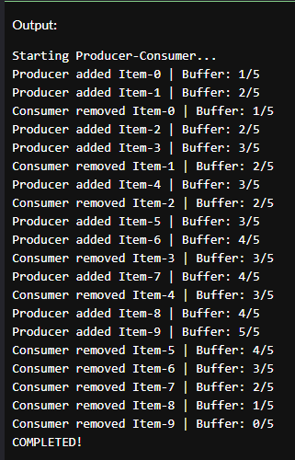

How Semaphores Prevent Race Conditions:
Semaphore | Purpose | Value Change
empty | Counts empty slots in buffer | Decreases when producer adds; increases when consumer takes
full | Counts filled slots in buffer | Increases when producer adds; decreases when consumer takes
mutex | Ensures only one thread accesses buffer at a time | Acquired when entering critical section; released after

Safety Guarantee: Only one thread accesses the buffer at a time, so no corruption!

Question 8: Page Replacement - FIFO vs LRU
Given Page Access Sequence: [2, 1, 4, 2, 3, 4, 3]
Frame Size: 3 (can hold 3 pages at once)
FIFO (First-In-First-Out)
Replace the oldest page in memory.
Step | Page | Frames After | Page Fault?
1 | 2 | [2] | Yes
2 | 1 | [2, 1] | Yes
3 | 4 | [2, 1, 4] | Yes
4 | 2 | [2, 1, 4] | No (already there)
5 | 3 | [1, 4, 3] | Yes (remove 2, oldest)
6 | 4 | [1, 4, 3] | No (already there)
7 | 3 | [1, 4, 3] | No (already there)

Total FIFO Page Faults: 4
LRU (Least Recently Used)
Replace the page not used for the longest time.
Step | Page | Frames After | Page Fault?
1 | 2 | [2] | Yes
2 | 1 | [2, 1] | Yes
3 | 4 | [2, 1, 4] | Yes
4 | 2 | [1, 4, 2] | No (mark 2 as recent)
5 | 3 | [4, 2, 3] | Yes (remove 1, least recent)
6 | 4 | [4, 2, 3] | No (already there)
7 | 3 | [4, 2, 3] | No (already there)

Total LRU Page Faults: 4
Comparison
Algorithm | Page Faults | Best When
FIFO | 4 | Rarely optimal; simple but not smart
LRU | 4 | Access patterns have locality (pages used recently will be used again)

Conclusion: LRU generally performs better than FIFO in real systems because programs tend to reuse recently-accessed pages (temporal locality principle).
Part C: Distributed Systems
Question 9: Designing a Distributed File System
a) Two Critical Issues in Distributed OS Design
Issue 1: Consistency in File Sharing
Problem: Files are stored across multiple servers. When two users access the same file from different locations:
- User A modifies the file on Server 1
- User B reads the file from Server 2
- Should User B see User A's changes immediately?
Challenges:
- Network delays: Changes take time to propagate
- Caching: Each server caches files locally for speed
- Conflicts: What if both users modify the same file simultaneously?
Issue 2: Resource Management & Load Balancing
Problem: Multiple users and devices share limited server resources.
Challenges:
- One server might become overloaded (too many requests)
- Other servers might be underutilized
- Need automatic load balancing to distribute work
- Failure handling: If one server crashes, work must move elsewhere
b) Architectural Approaches for Distributed File Management
Approach | How It Works | Benefits
Client-Server with Replication | Files replicated across multiple servers; clients read from nearest/fastest server | Improves performance and availability; if one server fails, copies exist elsewhere
Distributed Lock Manager (DLM) | Central lock service coordinates file access across all servers; prevents simultaneous conflicting modifications | Prevents data corruption when multiple clients access same file
Caching with Coherence Protocol | Servers cache files locally but maintain consistency using coherence protocol (similar to CPU caches) | Fast access through caching; consistency through protocol

Recommended Architecture: Combine all three:
- Replicate files across multiple data centers
- Use DLM to manage concurrent access
- Cache aggressively with coherence protocol
This ensures performance, consistency, and fault tolerance.
Question 10: Synchronous vs Asynchronous Checkpointing
What is Checkpointing? Periodically save system state so recovery is possible after failure.
Synchronous Checkpointing
How It Works:
- Coordinator tells all nodes: "Stop! Checkpoint now!"
- All nodes freeze current execution
- All nodes save their state to stable storage
- All nodes synchronize timestamps
- All nodes resume execution
Visual Example:
Time: 0s 1s 2s 3s 4s 5s
Node 1: [Running] [STOP] [Save] [Sync] [Resume] [Running]
Node 2: [Running] [STOP] [Save] [Sync] [Resume] [Running]
Node 3: [Running] [STOP] [Save] [Sync] [Resume] [Running]
←—— All synchronized ——→

Strengths:
- ✅ Global Consistency: All checkpoints aligned - safe recovery to any checkpoint
- ✅ Easy Recovery: All nodes at same state; simple rollback
- ✅ Transparent: Application doesn't need to manage checkpoints
Weaknesses:
- ❌ High Blocking Time: All nodes stop (entire system pauses)
- ❌ Scalability Issue: With many nodes, coordination overhead grows
- ❌ Performance Penalty: Frequent synchronization slows everything
Asynchronous Checkpointing
How It Works:
- Each node saves state independently, whenever it wants
- No global synchronization
- Nodes continue running without waiting for others
Visual Example:
Time: 0s 1s 2s 3s 4s 5s
Node 1: [Running] [Save] [Running] [Save] [Running]
Node 2: [Running] [Running] [Save] [Running] [Save]
Node 3: [Save] [Running] [Running] [Save] [Running]
←— Each independent ——→
Strengths:
- ✅ No Blocking: Nodes never stop; continuous progress
- ✅ High Performance: Minimal overhead
- ✅ Scalability: Works well with many nodes
- ✅ Better for IoT/Edge: Devices can checkpoint independently
Weaknesses:
- ❌ Recovery Complexity: Checkpoints not aligned; need to reconstruct consistent state
- ❌ Cascading Rollbacks: Recovering to one node's checkpoint might require rolling back others
- ❌ Data Loss Risk: If recovery isn't done carefully, some committed work might be lost

Comparison Table
Aspect | Synchronous | Asynchronous
Blocking Time | High | None
Consistency | Easy to ensure | Complex
Recovery | Simple | Complex (may need cascade)
Performance | Slower | Faster
Scalability | Poor | Good
Best For | Small systems, critical applications | Large distributed systems, edge computing

Recommendation:
- Use Synchronous for small distributed databases where consistency is critical
- Use Asynchronous for large-scale systems like cloud data centers
Question 11: Smart Home IoT Scheduling
Scenario: Smart home with cameras, lights, locks, temperature sensors. Need to prioritize security over comfort.
a) Process Scheduling Strategy
Priority Levels:
- Critical (Highest): Security devices - Camera motion detection, door lock alerts
- High: Safety - Fire/smoke detectors, temperature warnings
- Medium: Regular - Light automation, routine tasks
- Low: Non-critical - Statistics collection, logging
Recommended Algorithm: Priority Preemptive Scheduling
How It Works:
- Assign priority number to each device's task (1=Critical, 4=Low)
- Always run the highest priority ready task
- If high-priority task arrives, pause lower-priority task
- Return to lower-priority when high-priority completes
Justification:
- Security first: If camera detects break-in, it must execute immediately
- Preemption: Can interrupt light dimming to handle security event
- Fairness: Low-priority tasks still run when no urgent events occur
b) Inter-Process Communication (IPC) Methods for IoT
Best IPC Methods:
IPC Method | Use Case | Why Suitable
MQTT (Publish-Subscribe) | All devices send events to central hub | Lightweight, efficient; perfect for IoT; handles device failures gracefully
Message Queues | Pass security alerts between services | Reliable delivery with persistence; if consumer crashes, message waits
Shared Memory | Fast local communication between nearby modules | Ultra-fast for local sensors on same gateway; minimal latency
REST API | Remote device queries (e.g., check camera feed) | Stateless, scales well; easy for cloud integration

Question 12: Linux System Calls Demo
Objective: Demonstrate OS system calls for file operations and threading.
Linux is selected as the operating system for this case study. The goal is to show how a simple Python program uses Linux system calls indirectly to create, read, inspect, and delete a file.
import os
FILENAME = "linux_demo.txt"
DATA = "Hello from a Linux file system call demo in Python!\n"
def main():
print("=== Python File Demo on Linux ===\n")
# STEP 1: Create and write a file
# This uses high-level Python I/O, which internally calls Linux sys_open and sys_write.
print("STEP 1: Creating and writing file...")
with open(FILENAME, "w", encoding="utf-8") as f:
f.write(DATA)
print(f" Wrote text to {FILENAME}\n")
# STEP 2: Read the file back
# Internally mapped to Linux sys_open and sys_read.
print("STEP 2: Reading file...")
with open(FILENAME, "r", encoding="utf-8") as f:
content = f.read()
print(" File content:")
print(" ", content)
# STEP 3: Get file metadata using os.stat
# This wraps the Linux stat() system call.
print("STEP 3: File metadata (stat):")
st = os.stat(FILENAME)
print(f" Size: {st.st_size} bytes")
print(f" Permissions (octal): {oct(st.st_mode & 0o777)}")
print(f" Inode number: {st.st_ino}")
print()
# STEP 4: Delete the file using os.remove (unlink system call)
print("STEP 4: Deleting file...")
os.remove(FILENAME)
print(" File deleted. Demo complete.")
if __name__ == "__main__":
main()
- Linux provides system calls such as open, read, write, stat, and unlink to allow user programs to work with files. Python’s open(), os.stat(), and os.remove() are high-level wrappers that eventually invoke these underlying system calls through the C library, which triggers a switch from user mode to kernel mode.​
- This program demonstrates the file abstraction offered by the operating system. The Python code never manipulates disk blocks directly; instead, it treats the file as a simple stream of bytes, while the Linux kernel handles details like locating the inode, managing the file descriptor, caching data, and scheduling disk I/O.​
- Security and protection are also illustrated. When open() or os.stat() are called, the kernel checks file permissions (read/write bits in the mode field) before allowing access, enforcing the access control policy defined by the Linux permission model

